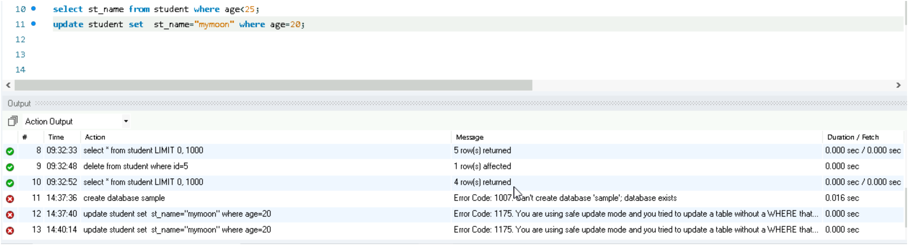
sometimes we may face errors while updating some records, This is due to safe update mode. This mode prevents accidental updates or deletions without a WHERE clause that uses a key column.

To solve this problem write the query SET SQL_SAFE_UPDATES = 0;

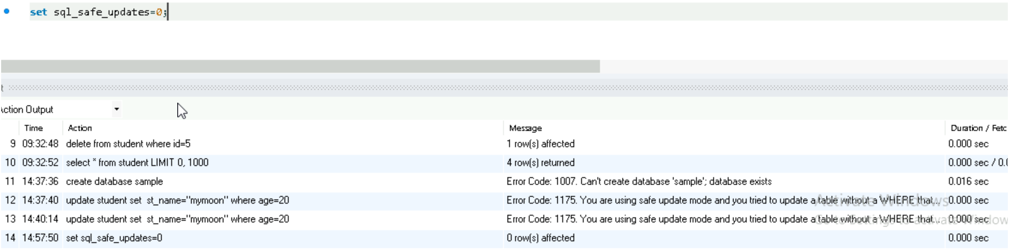
this will disable safe update mode. Then you can write write update query

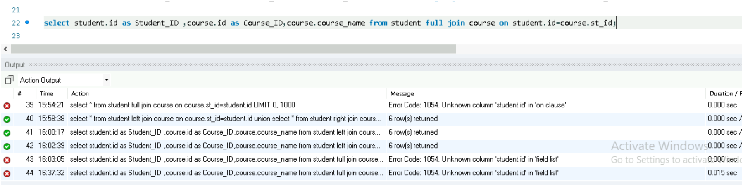
There is a chance to get an error while using FULL JOIN. So We find the full join by using another logic,ie the combination of LEFT JOIN and RIGHT JOIN.
First we need to find LEFT JOIN and then find the RIGHT JOIN. Combine this into one using UNION.
It will preserve the records from LEFT JOIN and RIGHT JOIN,and common records in both tables while removing the duplicate entries.
